**Save lives by learning basic actions to stop life threatening bleeding following everyday emergencies and man-made and natural disasters.**

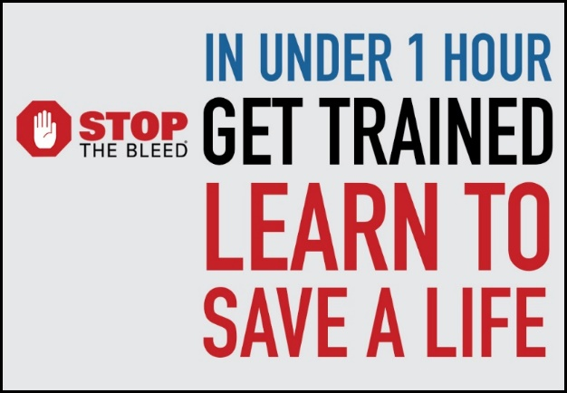**Uncontrolled bleeding is the #1 cause of PREVENTABLE death from trauma.**



**This FREE training is provided by:** 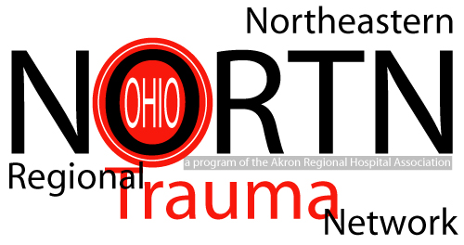

**For more information or to schedule a class, contact Niki:** [yostn@ccf.org](mailto:yostn@ccf.org) or (330)313-2911  
