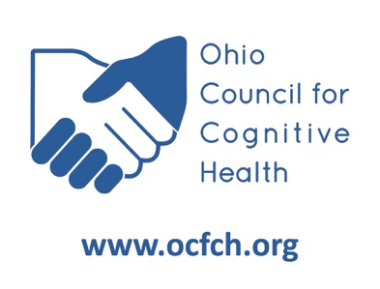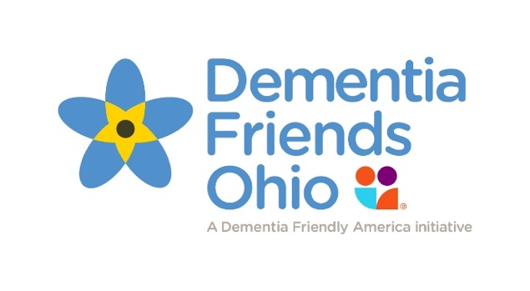

February 22, 2024

Barbara White

DATE PRESENTED

DEMENTIA FRIENDS CHAMPION

PRESENTED TO

___

**Dementia Friends Ohio**

Certificate of Completion