DOWNTOWN AKRON PARTNERSHIP
PARTICIPATION FORM
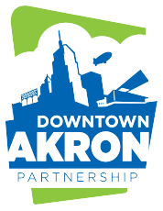

Instructions
Complete the form in its entirety, including a signature from the Downtown Akron Partnership program leader to receive Virgin Pulse Points. Please return the completed form to the Wellness Team via email or drop it off at our office.

Employee Information and Activity Details
Employee Name |  | Employee ID (8-digits)
E-mail |  | Phone
Office |  | Department/Agency

Activity Date |  |  | Program | Activity
Monday
Tuesday
Wednesday
Thursday
Friday
Saturday
Sunday

Signature |  |  | Name
 | Signature of Participating Employee Submitting this Form |  |  | DAP Program Leader (print)

Date of Signature |  |  |  |  |  | Signature
 | MM |  | DD |  | YY |  |  | Signature of DAP Program Leader

County of Summit | Employee Benefits
1180 S. Main Street | Suite 378 | Akron, Ohio 44301

